1. Create a function module to import a range of customer numbers and export the customer data for the given range.

Customer Data can be found in table KNA1.

Time : 30 minutes

Create a package and keep all objects created for this task in that package.

Paste screenshots of all the objects created for this task.

**PACKAGE:** ZZML_UST

**FUNCTION MODULE:** ZML14JUL_FMOD

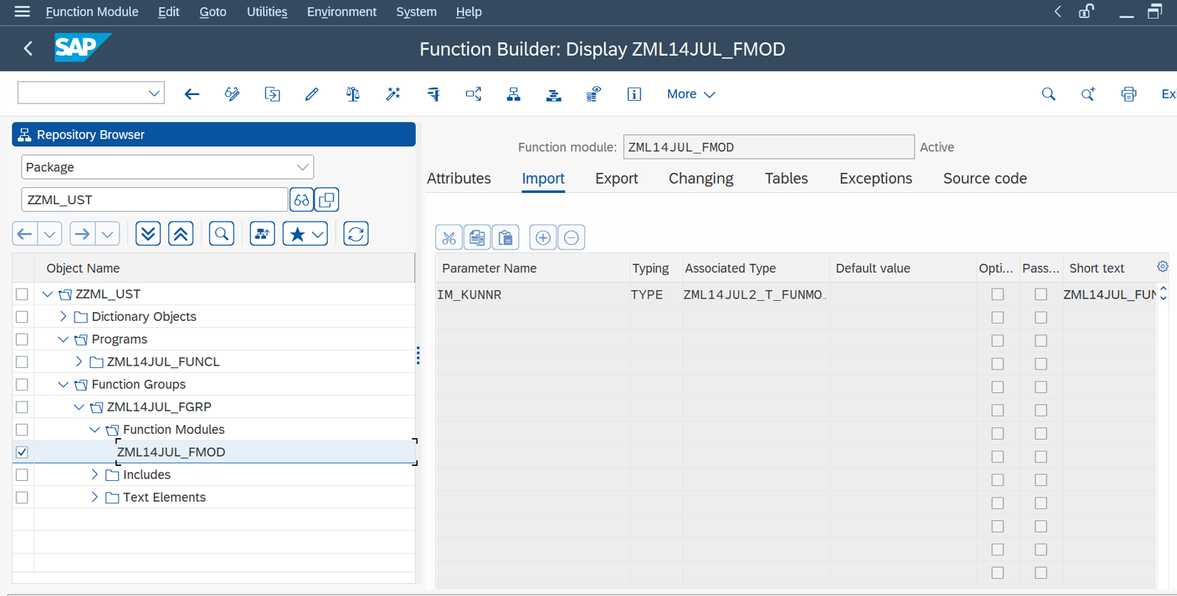

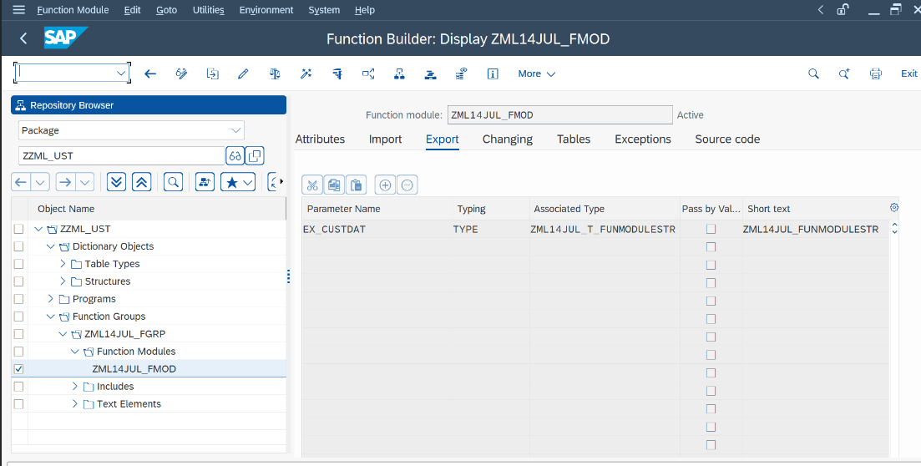

**STRUCTURES AND TABLE TYPES**:

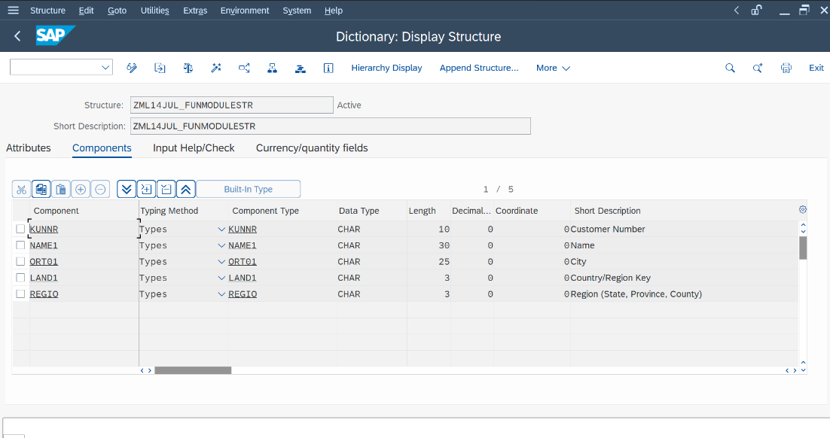

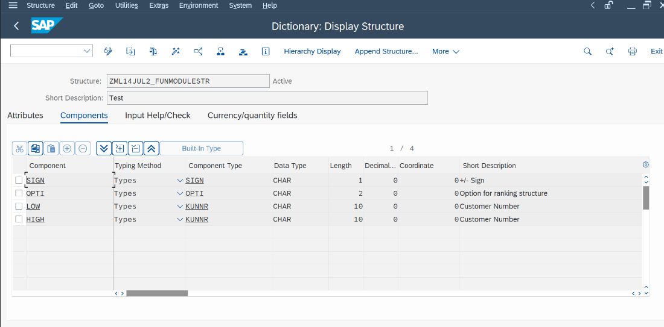

**PROGRAM:** ZML14JUL_FUNCL

**OUTPUT:**

